During the period from November 5 to 9, 2018, I participated in the implementation of teaching mobility within the framework of the Erasmus project + direction K107 - ICM "International Credit Mobility" at the University of Turkey - Afyon Kocatepe University.
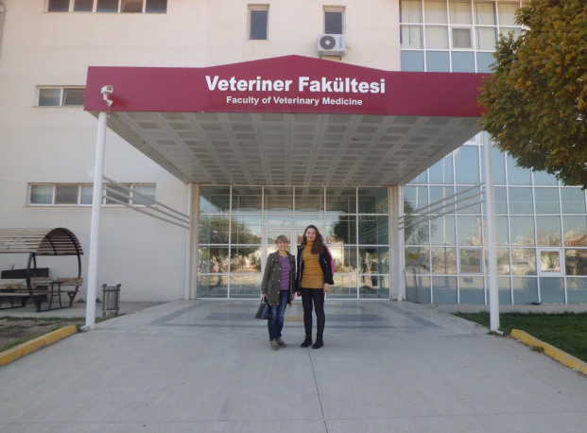
The main purpose of my visit was to give lectures in English to Turkish students of the Faculty of Veterinary Medicine. The total volume of lectures was 8 academic hours in the direction "Parasitology of zoonotic helminthoses":
- 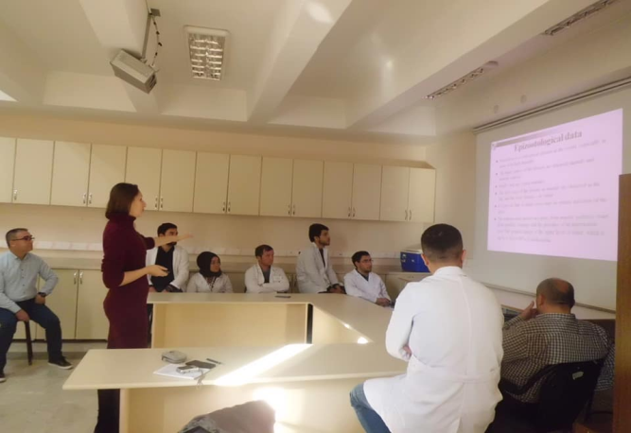Lecture 1 (2 hours): Methods of animal faeces’ helminthological study
- Lecture 2 (2 hours): Trematodoses of ruminant animals
- Lecture 3 (2 hours): Larval cestodoses of ruminant animals
- Lecture 4 (1 hour): Echinococcosis
- Lecture 5 (1 hour): Toxocarosis

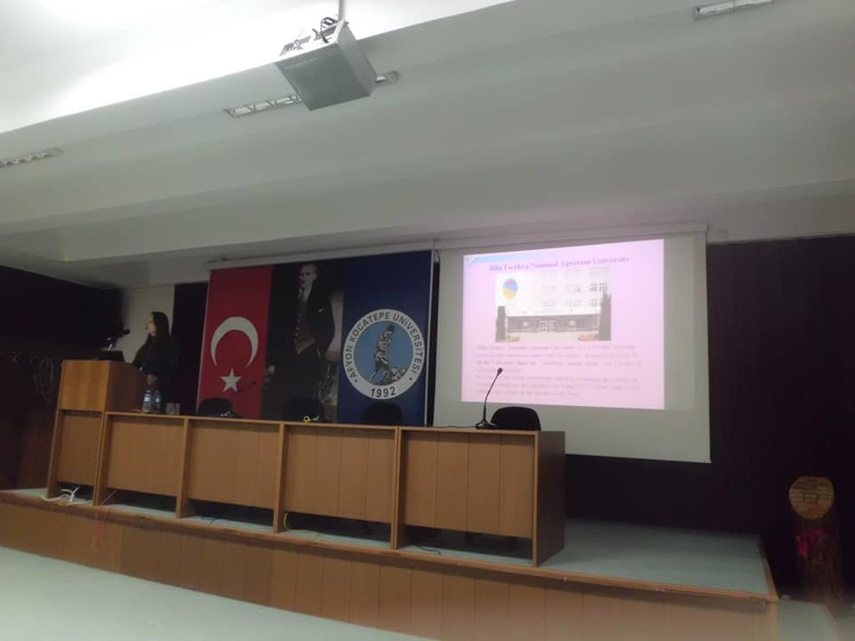Students of the graduate courses at the Faculty of Veterinary Medicine took interest in the material with enthusiasm and actively asked questions at the end of the lectures. Such an active interaction struck and inspired me to further professional self-improvement.
In addition to the lectures, the staff of the Faculty of Veterinary Medicine organized exciting excursions both within and outside the campus. So, it was extremely interesting to visit a training farm that specializes in keeping water buffalo. From this type of cattle, milk is obtained, which is marked by high nutrition, which is further processed into yoghurt and cream in a specialized laboratory.
Our visits to the Faculty's laboratories were extremely interesting. Pleasantly impressed by the high qualification of staff, the level of equipment and interesting research conducted at the faculty.
We also visited the clinics of small and farm animals, the Department of Laboratory Animals, a unique wildlife rehabilitation center.
In general, I want to note the warm welcome and care shown to us by Turkish colleagues.
For all my colleagues from different countries, I will advise - if you have the opportunity to participate in the Erasmus + project, be sure to do it, get invaluable and incomparable experience!

